1. Introduction
1.1. Purpose
This document describes the design and architecture of the Sensor module, the software component that wraps the ADC driver and exposes a domain-specific interface for reading an analog sensor — in this lab, a 10 kΩ potentiometer connected to PA0. It provides details on data types, control flow, and the public API used by the application layer (main.c). The intent is to give any developer reading this document enough context to understand, maintain, extend, or replicate the module without having to reverse-engineer the source code.
Unlike the ADC driver, which lives in the driver layer and talks directly to ADC1 registers, the Sensor module sits one layer above. It does not touch any hardware register itself; instead it composes a small set of ADC driver calls into three operations that are meaningful to the application: initialize the sensor, start a conversion, and read the latest value. The module is intentionally thin — its job is naming and composition, not hardware abstraction.
1.2. Scope
The Sensor module is a middleware component for embedded systems running on the STM32F411RE. It abstracts the multi-step ADC initialization sequence (reset, enable instance, configure channel) into a single sensor_init call, exposes a one-line conversion start, and provides a single read function that widens the 12-bit ADC result into a uint32_t for convenient use by the application.
The module is parameterized by ADC instance and channel, so the same source code works regardless of which ADC channel the sensor happens to be connected to. In this lab the application connects a potentiometer to PA0 (ADC1 channel 0), but moving the sensor to a different pin requires no changes to the module — only the constants in main.c need to be updated. The module depends only on the ADC driver and on stdint.h; there is no dependency on STM32 HAL, CMSIS device headers, or any third-party library.
1.3. Definitions, Acronyms, and Abbreviations
Term | Definition
ADC | Analog-to-Digital Converter. The peripheral that translates an analog input voltage into a digital number. Used by this module through the ADC driver.
MCU | Microcontroller Unit. The STM32F411RE in this project.
Sensor | In this document, the abstract concept of an analog input device. In this lab the sensor is a 10 kΩ potentiometer wired between 3.3 V and ground, with the wiper connected to PA0.
Middleware | Software layer that sits between low-level drivers and the application, adapting driver primitives to a domain-specific interface.
API | Application Programming Interface. The set of public functions exposed by the module.
SRS | Software Requirements Specification.
SDD | Software Design Document — this document.
FR | Functional Requirement, as listed in the SRS.
NFR | Non-Functional Requirement, as listed in the SRS.
1.4. Requirements
All requirements specific to this module are allocated alongside the analog-sensor task description in the lab repository at https://github.com/MasterCarlosV/MSE_LabCourse. The module exposes an API that satisfies the analog-sensor portion of the lab brief: a single initialization call, a single conversion-start call, and a single value-read call. Every public function returns a status code of type sensor_status_t so that error conditions from the underlying ADC driver are propagated cleanly to the application.
2. System Architecture
2.1. High-Level Design
The Sensor module sits in the middleware layer of a four-layer architecture. Each layer talks only to the one immediately below it. This separation is what makes the module reusable: if the potentiometer were ever moved to a different ADC channel, or replaced with a different analog sensor (e.g., a thermistor or a photoresistor), only one layer would change.
- Application Layer — main.c. Calls sensor_init, sensor_startConversion, and sensor_readValue, then maps the raw 12-bit result onto a PWM duty cycle. Never accesses ADC registers and never touches the ADC driver directly.
- Sensor Module Layer — sensor.c/.h. Composes ADC driver calls into the three public functions documented in this SDD. Owns the analog-sensor concept (which channel, which instance) but does not own the ADC hardware itself.
- ADC Driver Layer — adc_driver.c/.h. Implements the register-level API consumed by the Sensor module.
- Hardware Layer — STM32F411RE ADC1 peripheral registers, mapped at fixed addresses on the APB2 bus (base 0x40012000).
Figure 1 shows the dependency graph of the Sensor header. Two files include sensor.h: the implementation file sensor.c and the application entry point main.c. This is the desired pattern — the application reaches the ADC subsystem only through the Sensor module.
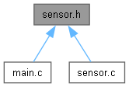
Figure 1. Files that depend on sensor.h. The module is consumed by the application (main.c) and implemented by sensor.c.
2.2. Module Interfaces
The public API is defined in sensor.h. It exposes three functions covering initialization, conversion start, and result read. Module-level dependencies are minimal — only the C standard header stdint.h, plus adc_driver.h for the types and functions of the underlying driver. There is no dependency on STM32 HAL, CMSIS device headers, or any third-party library.
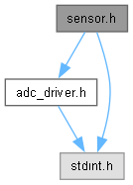
Figure 2. Headers included by sensor.h. The module re-exports the ADC driver types so the application can pass Adc_Instance_t and Adc_Channel_t values without including adc_driver.h itself.
Figure 3 shows the inclusion graph of main.c, which reaches the ADC driver only indirectly through sensor.h. This is the structural property the architecture is meant to enforce: no edge in the include graph goes from main.c to adc_driver.h directly.
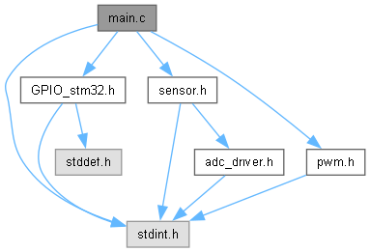
Figure 3. Inclusion graph for main.c. Sensor access flows through sensor.h, which transitively pulls in adc_driver.h.
3. Detailed Design
3.1. Class Diagram
The Sensor module does not define a struct or class — it is a stateless function library that delegates all work to the ADC driver. The only data type it owns is the sensor_status_t enumeration, which is the return type of every public function. Because there is no in-memory layout to document, this section instead describes the conceptual ownership of state.
All persistent state (the configured channel, the ADC peripheral's enable flag, the regular sequence registers) lives inside the ADC peripheral itself, written by the ADC driver during sensor_init. The Sensor module passes through the ADC instance argument on every call so the underlying driver can locate the correct peripheral, but the module itself never caches that argument or any other state. This design choice keeps the module lightweight and re-entrant — multiple sensor instances on different channels could coexist with no changes to the module's source.
3.2. Module Behavior (Sequence Diagrams, State Machines, etc.)
This subsection describes the runtime behavior of the module, focusing on how the application calls into it and how the module in turn calls into the ADC driver. The figures below are call graphs generated automatically from the source.
Figure 4 is the global call graph rooted at main(). The three Sensor functions appear as direct children of main, and each fans out into one or more ADC driver primitives. No edge in the graph skips the Sensor module to reach the ADC driver directly — confirming the layering enforced by the include graph in Figure 3.
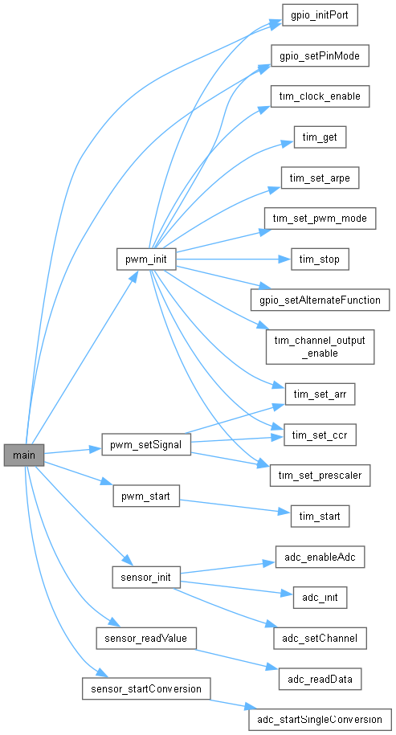
Figure 4. Sequence Diagram — Global call graph rooted at main(). The Sensor module sits between main and the ADC driver; every analog read goes through it.
Figure 5 details the call graph for sensor_init(), the most complex of the three public functions. It fans out into three ADC driver calls executed in a fixed order: adc_init() to reset the ADC and gate its clock to a known state, adc_enableAdc() to power up the analog block and enable the requested instance, and adc_setChannel() to load the requested channel into the first slot of the regular sequence. If any of the three returns an error, sensor_init aborts immediately and propagates SENSOR_ERR to the caller — the application is responsible for deciding what to do next (typically: enter an error loop).
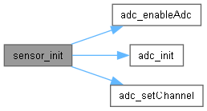
Figure 5. Activity Diagram — Driver Init sequence triggered by sensor_init(). The three driver calls match the standard ADC initialization order: reset → enable → configure channel.
Figure 6 shows the call graph for sensor_startConversion(). It is a one-line wrapper that delegates to adc_startSingleConversion(), translating the driver's Adc_Status_t result into the module's sensor_status_t. This is an example of a driver action with a conditional — the conditional is the busy-flag check inside the ADC driver, which the module surfaces as SENSOR_ERR if a conversion is already in progress.
Figure 6. Sequence Diagram — Driver Action with Conditional. sensor_startConversion() delegates to adc_startSingleConversion(), gated by a busy-flag check inside the driver.
Figure 7 illustrates the runtime call path for sensor_readValue(), which delegates entirely to adc_readData(). This represents the steady-state polling action invoked from the main loop — effectively a driver action executed inside a loop in the application layer. The module widens the 16-bit result returned by adc_readData into a uint32_t before storing it through the caller's pointer, which makes the value easier to use in arithmetic without explicit casts in the application code.
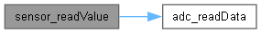
Figure 7. Activity Diagram — Driver Action with Loop. sensor_readValue() is called repeatedly from the main loop and forwards each invocation to adc_readData().
3.3. Sensor Module
The module is structured around a uniform delegate-and-translate pattern. Every public function performs the same three steps: it forwards its arguments to the corresponding ADC driver function, it inspects the returned Adc_Status_t, and it translates that status into either SENSOR_OK or SENSOR_ERR. This is the entire role of the module — it does not validate arguments itself (the ADC driver already does that), it does not retry on failure, and it does not maintain any internal state between calls.
The translation from Adc_Status_t to sensor_status_t deliberately collapses every error into a single SENSOR_ERR. This loses information — the application can no longer distinguish ADC_ERROR_INVALID from ADC_ERROR_BUSY from ADC_ERROR_TIMEOUT — but it also keeps the API tiny, which matches the design philosophy of a thin middleware layer. If the application needs to recover from specific ADC errors, it can call the ADC driver directly (at the cost of breaking the layering); in practice, for a potentiometer reading driving an LED, any error is recoverable by simply skipping the current iteration of the main loop, which is what main.c does.
Three implementation choices are worth highlighting:
- Initialization sequence is fixed. sensor_init always calls adc_init, then adc_enableAdc, then adc_setChannel, in that order. This matches the order required by RM0383 (the peripheral cannot be configured before its clock is enabled, and the clock cannot be enabled before the peripheral is reset). Because the order is fixed inside the module, the application cannot get it wrong.
- Result widening to uint32_t. adc_readData returns a uint16_t, but sensor_readValue stores the result through a uint32_t* pointer. The widening is intentional: the application maps the ADC reading onto a duty-cycle value via integer arithmetic (raw * 100 / 4095), and using uint32_t avoids any risk of overflow in the multiplication step. The cost is two bytes of stack memory in the caller's frame, which is negligible.
- Null-pointer check before delegation. sensor_readValue checks that the output pointer is non-NULL before forwarding to the ADC driver, even though the driver also performs the check. The redundant check is cheap and lets the module return SENSOR_ERR cleanly without consuming a conversion result. It also documents to the reader that NULL is an explicit error condition at the module boundary.
The module does not provide a deinit function. Once initialized, the ADC peripheral remains powered for the rest of the program's lifetime. This is acceptable for the lab application but would need to be revisited for low-power designs (see Section 5).
4. Application Programming Interfaces
4.1. Data Types and Macros
The Sensor module defines a single public type in sensor.h. It does not define any macros of its own; the ADC instance and channel identifiers used in the API are imported from adc_driver.h.
Enumerations
sensor_status_t: This enumerated type represents the return status of every public function in the module. It collapses the ADC driver's richer error space into a binary success/failure result.
Member Name | Type | Notes/Definition
SENSOR_OK | uint32_t | 0 — Operation completed successfully. The underlying ADC driver returned ADC_OK.
SENSOR_ERR | uint32_t | 1 — Operation failed. The underlying ADC driver returned a non-OK status, or a NULL output pointer was supplied.
Imported Types
The following types are imported transitively from adc_driver.h and used in the public API of the Sensor module. Refer to the ADC Driver SDD for their detailed definitions.
Member Name | Type | Notes/Definition
Adc_Instance_t | enum | Identifier of the ADC peripheral. The module accepts ADC_INSTANCE_1 (the only instance present on the F411).
Adc_Channel_t | enum | Identifier of the input channel. The module accepts ADC_CHANNEL_0 through ADC_CHANNEL_15.
4.2. Error Codes
The Sensor APIs have a return type of sensor_status_t, a two-valued enumeration. Every public function returns one of the values listed below. A return value of SENSOR_OK indicates success; SENSOR_ERR indicates that the operation could not be completed.
Code | Notes/Definition
SENSOR_OK | 0x00 — Operation completed successfully. The underlying ADC driver call returned ADC_OK.
SENSOR_ERR | 0x01 — Operation failed. Emitted in any of the following situations: the ADC driver returned ADC_ERROR_INVALID (instance or channel out of range); the ADC driver returned ADC_ERROR_BUSY (a conversion was already in progress when sensor_startConversion was called); the ADC driver returned ADC_ERROR_TIMEOUT (no EOC flag was set when sensor_readValue was called); or the output pointer passed to sensor_readValue was NULL.
4.3. Function Definitions
This section documents the three public functions exposed by the Sensor module. Each function table follows the standard SDD format and includes signature, parameters, return value, description, constraints, and the header file where it is declared.
sensor_init
Function Name | sensor_init
Syntax | sensor_status_t sensor_init(Adc_Instance_t instance, Adc_Channel_t channel);
Parameters (in) | instance | Identifier of the ADC instance to use. Typically ADC_INSTANCE_1 on the F411.
 | channel | Identifier of the input channel the sensor is connected to (0–15). For the lab potentiometer on PA0, this is ADC_CHANNEL_0.
Parameters (inout) | None
Parameters (out) | None
Return value | sensor_status_t | SENSOR_OK if all three underlying ADC driver calls succeed; SENSOR_ERR if any of them fails.
Description | Initializes the analog sensor by composing three ADC driver calls in the required order: adc_init() to reset the ADC subsystem, adc_enableAdc() to enable the requested instance and power up the analog block, and adc_setChannel() to load the requested channel into the first slot of the regular sequence. After this call returns SENSOR_OK, sensor_startConversion and sensor_readValue can be used freely.
Constraints | The GPIO pin physically connected to the chosen ADC channel must already be configured in analog mode (in the lab application this is done in main.c by calling gpio_setPinMode(GPIO_PORT_A, GPIO_PIN_0, GPIO_MODE_ANALOG) before sensor_init). The module does not perform that step itself, because it has no opinion about which physical pin the sensor is wired to.
Available via | sensor.h
sensor_startConversion
Function Name | sensor_startConversion
Syntax | sensor_status_t sensor_startConversion(Adc_Instance_t instance);
Parameters (in) | instance | Identifier of the ADC instance to operate on. Must match the instance previously passed to sensor_init.
Parameters (inout) | None
Parameters (out) | None
Return value | sensor_status_t | SENSOR_OK if the underlying adc_startSingleConversion returned ADC_OK; SENSOR_ERR otherwise (typically ADC_ERROR_INVALID or ADC_ERROR_BUSY translated to SENSOR_ERR).
Description | Starts a single regular conversion on the channel previously configured by sensor_init. Delegates entirely to adc_startSingleConversion, which writes the SWSTART bit (bit 30 of CR2) after confirming no conversion is already in progress. The function returns immediately; the actual conversion happens asynchronously, and the caller must invoke sensor_readValue after a short delay (or after polling) to retrieve the result.
Constraints | sensor_init must have completed successfully before this call. Issuing two starts back-to-back without an intervening read will return SENSOR_ERR on the second call (the underlying driver detects the busy condition).
Available via | sensor.h
sensor_readValue
Function Name | sensor_readValue
Syntax | sensor_status_t sensor_readValue(Adc_Instance_t instance, uint32_t *value);
Parameters (in) | instance | Identifier of the ADC instance to read from. Must match the instance previously passed to sensor_init.
Parameters (inout) | None
Parameters (out) | value | Pointer to a uint32_t that will receive the latest 12-bit conversion result, widened to 32 bits. Must not be NULL.
Return value | sensor_status_t | SENSOR_OK if the underlying adc_readData returns ADC_OK; SENSOR_ERR if value is NULL or if the ADC driver returns a non-OK status (typically ADC_ERROR_TIMEOUT when EOC is not yet set).
Description | Reads the result of the latest regular conversion. Performs a NULL check on the output pointer, then delegates to adc_readData to obtain a uint16_t result, widens it to uint32_t, and stores it through *value. The widening makes the value easier to use in subsequent arithmetic — for example, the application multiplies it by 100 before dividing by 4095 to map the reading onto a 0–100 % duty cycle, an operation that would risk overflow in 16-bit arithmetic.
Constraints | A conversion must have been started by a previous call to sensor_startConversion before this call. The function does not block waiting for EOC — it is a snapshot read, not a wait-and-read. If the conversion is not yet complete the function returns SENSOR_ERR, and the application must retry.
Available via | sensor.h
4.4. Internal Function Definitions
The Sensor module does not define any internal (static) helper functions. The implementation of each public function is short enough — between three and six lines — that no shared logic emerged that would justify a separate helper. The module is, by design, a thin pass-through layer.
The only repetitive pattern across the three public functions is the translation of an Adc_Status_t into a sensor_status_t. In the current implementation this appears inline as a ternary expression (status == ADC_OK ? SENSOR_OK : SENSOR_ERR). If the API ever grows beyond three functions, factoring that pattern into a static inline helper would be a reasonable refactoring; for now it would add noise without saving lines.
5. Future Enhancements
The current module covers the requirements of this lab, but several extensions are natural next steps. The list below is ordered roughly by priority and effort.
- Richer error reporting. The current sensor_status_t collapses every ADC error into SENSOR_ERR. Extending the enum to include sensor-level error codes (e.g., SENSOR_ERR_NOT_INITIALISED, SENSOR_ERR_BUSY, SENSOR_ERR_TIMEOUT, SENSOR_ERR_NULL_PTR) would let the application distinguish between transient errors (worth retrying) and configuration errors (fatal).
- Built-in moving-average filter. Raw 12-bit ADC readings on a breadboarded source jitter by a couple of LSBs. For an LED driven by PWM this is invisible, but for a control loop or for displaying the value on a screen, a small moving-average filter inside sensor_readValue would smooth the output without changing the API. The window size could be a compile-time constant or a parameter to sensor_init.
- Voltage-domain conversion. sensor_readValue currently returns the raw 12-bit count. Adding a parallel sensor_readVoltage function that converts the count to millivolts (or to a calibrated engineering unit) would push more responsibility into the module and reduce duplication when the same sensor is used by multiple applications.
- Explicit GPIO setup inside sensor_init. The module currently assumes the analog pin has been put in MODE_ANALOG by the caller. Folding that step into sensor_init — taking a port and pin in addition to instance and channel — would close a class of configuration bugs at the module boundary, at the cost of giving the module a dependency on the GPIO driver.
- Multi-sensor support. The module is conceptually re-entrant (it caches no state) but has no API for managing multiple sensors at once. A sensor_handle_t struct that carries instance, channel, and possibly filter state would let the application instantiate one handle per analog input, all sharing the same underlying ADC peripheral, with the regular sequence reconfigured between reads.
- Deinit function. A sensor_deinit that asks the ADC driver to power down the analog block and gate its clock would be useful for low-power applications where the sensor is only sampled occasionally.

